|  |  |
| --- | --- |
|  |  |

**Data Source:** <https://www.kaggle.com/passnyc/data-science-for-good/home>

**Dataset Overview**

PASSNYC is a not-for-profit organization that facilitates a collective impact that is dedicated to broadening educational opportunities for New York City's talented and underserved students. New York City is home to some of the most impressive educational institutions in the world, yet in recent years, the City’s specialized high schools - institutions with historically transformative impact on student outcomes - have seen a shift toward more homogeneous student body demographics.

PASSNYC uses public data to identify students within New York City’s under-performing school districts and, through consulting and collaboration with partners, aims to increase the diversity of students taking the Specialized High School Admissions Test (SHSAT). By focusing efforts in under-performing areas that are historically underrepresented in SHSAT registration, we will help pave the path to specialized high schools for a more diverse group of students.

~ Kaggle.com

5 things I want to find out with respect to the schools in NYC

1. **Which Cities in New York Have the highest number of schools but are economically backward or in economic need?**

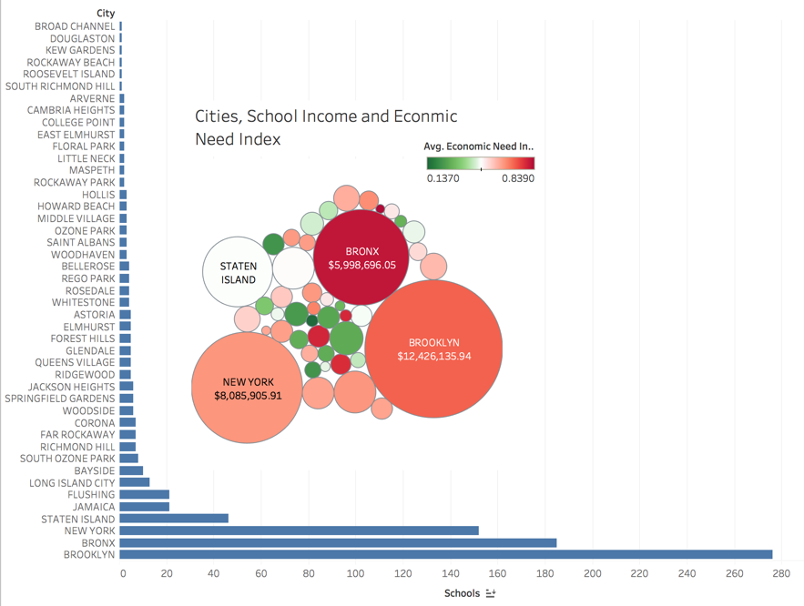

Brooklyn, Bronx and New York have the highest number of schools and have high school-income, but the average economic need index paints a different picture. The data shows that the schools in these three big cities are in economic need. Bronx seems to be the worst in terms of economic need index even though it ranks second in terms of the number of schools and third in terms of the total estimated school income.

1. **What is the relationship between ethnicity and economic need index?**

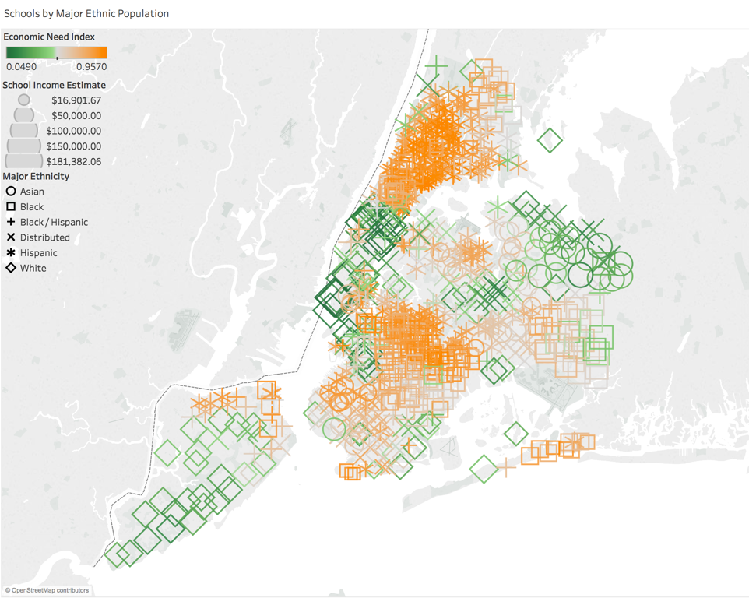The data suggests that certain areas in the map denoted by gold and red have particularly high ratio of students from one of the ethnic groups in the school. For example, schools in the north eastern part of New York have a high Asian student ratio and similarly, northern part has high Hispanic student ratio, south east and central part has high Black Student ratio, and finally south western part has high White Student ratio.

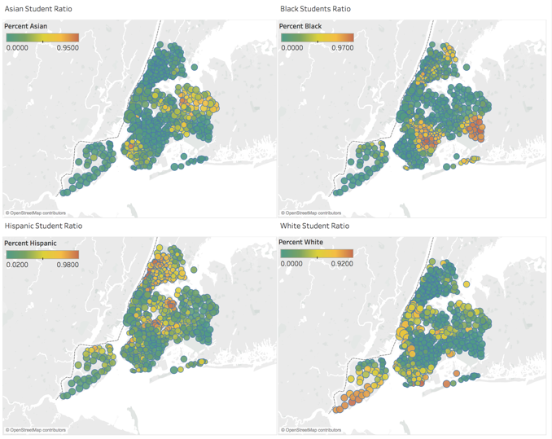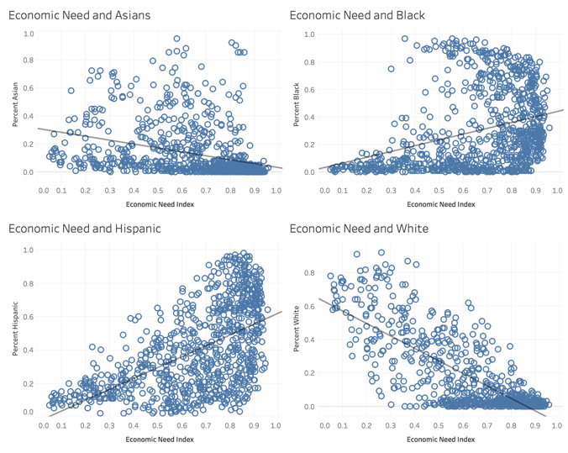

Furthermore, certain parts of New York score higher on the economic need index than other parts. On closer examination it becomes apparent that in general, the economic need index is negatively co-related with percent White and with percent Asian student ratio. At the same time, it is positively co-related with Percent Hispanic and with Percent Black student ratio.

1. **What is the relationship if any between ethnic/family background and grades?**

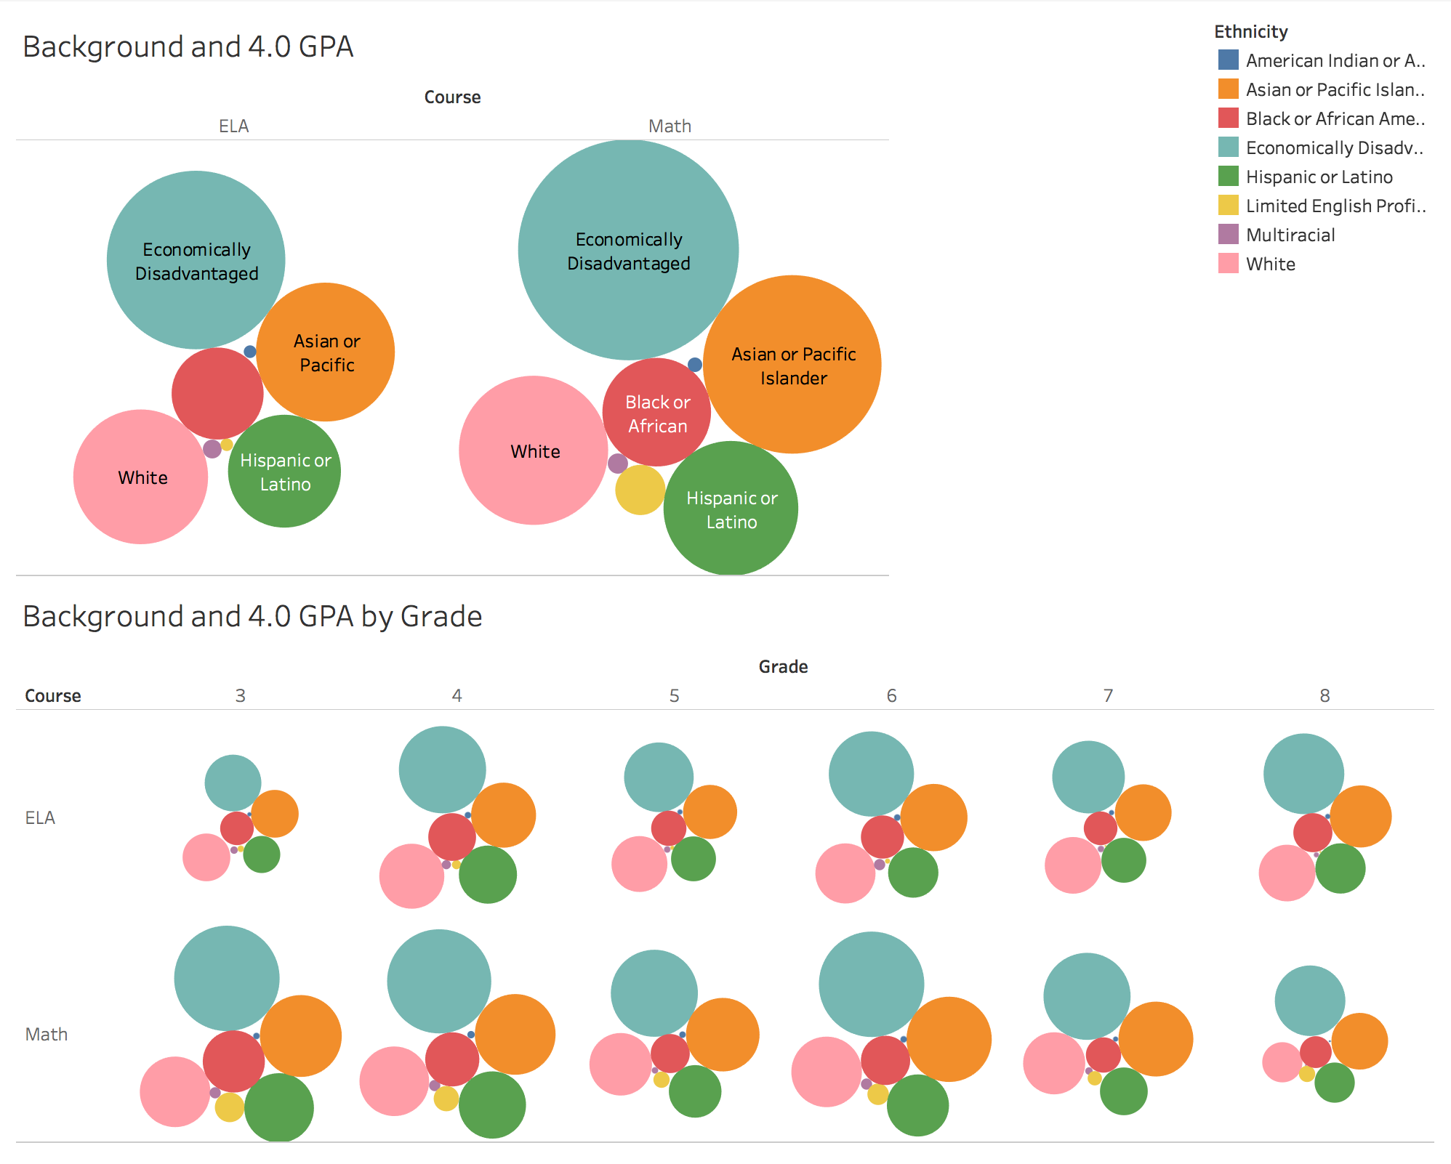

It seems people who are economically disadvantaged are performing better in schools, followed by Asian or Pacific Islander. It is interesting to note that the number of people getting 4.0 GPA is decreasing as the grades increase.

1. **What is the relationship, if any, between economic need and students being chronically absent?** 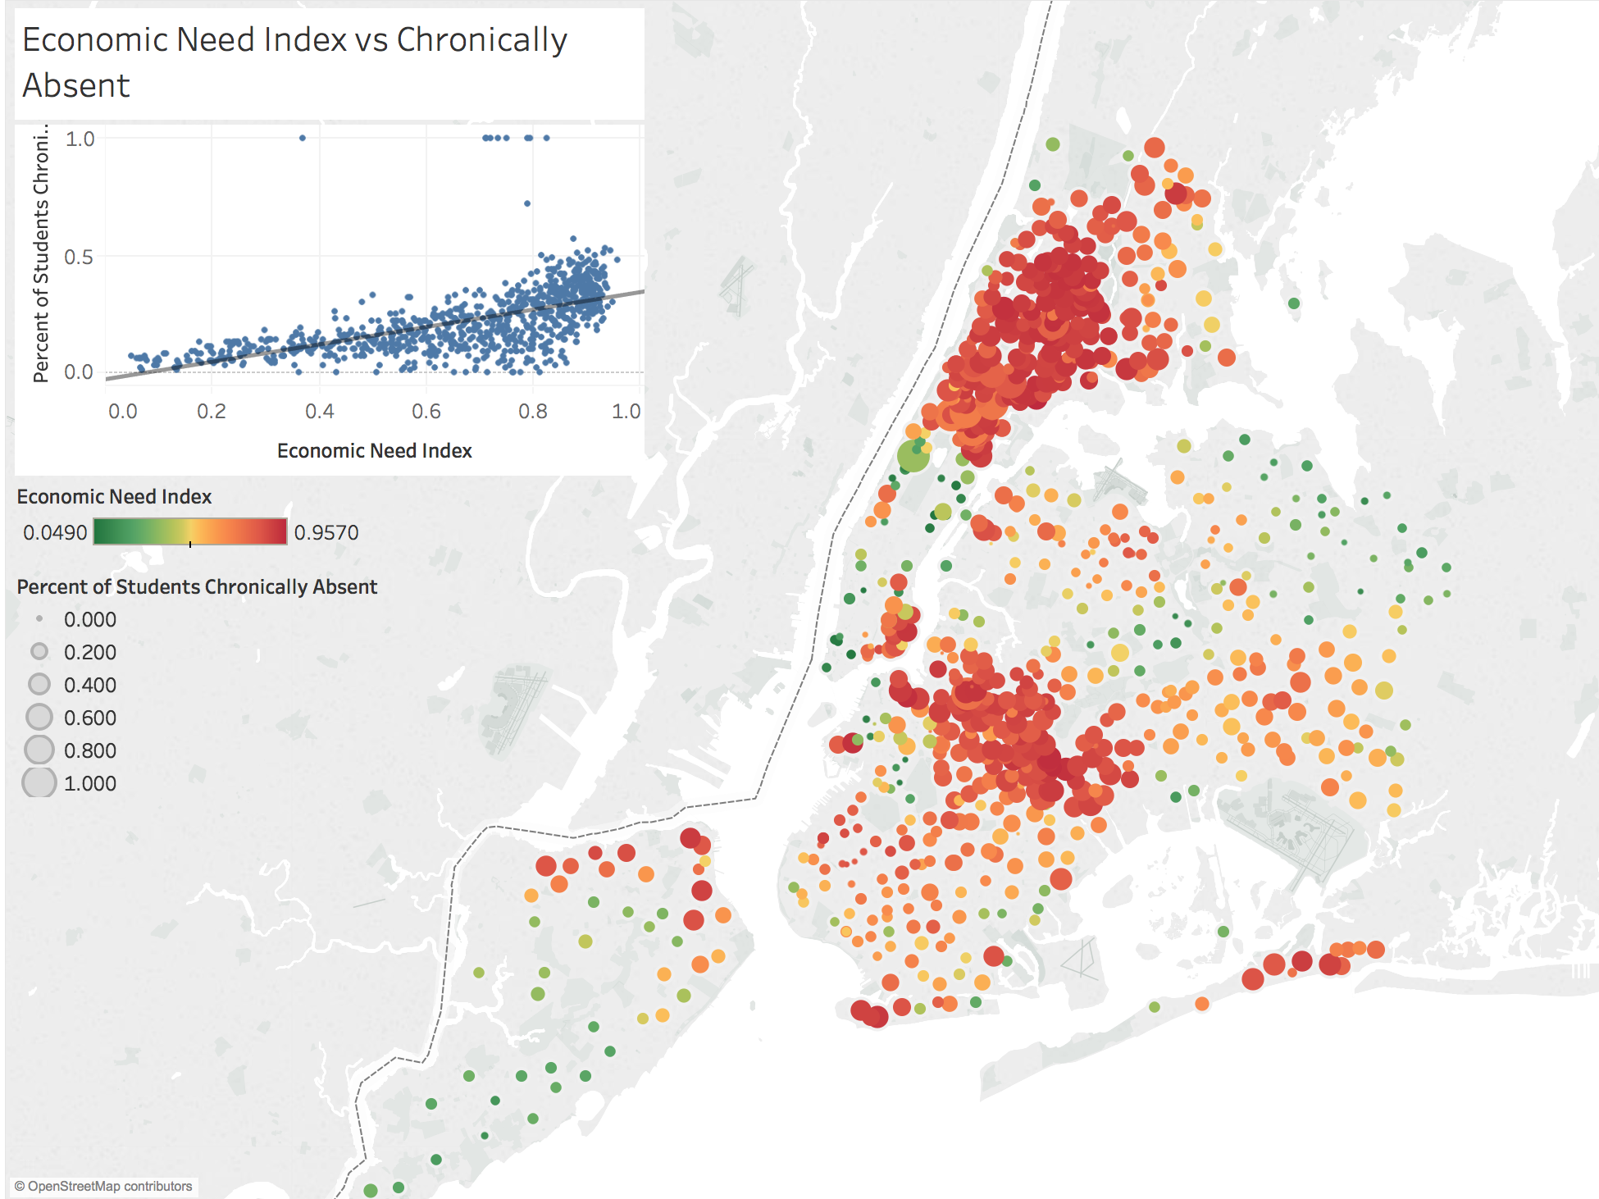

The data shows that economic need index has a positive co-relation with percentage of students chronically absent. The map visualization also confirms that the more the the more the economic need index, percentage of the number of students that are chronically absent.

1. **Does studying with people of different ethnic group improve GPA?**

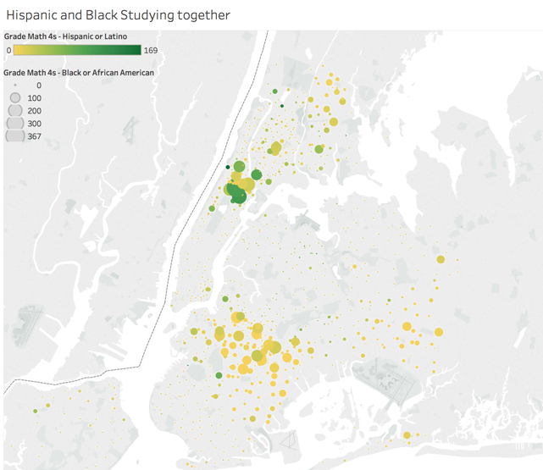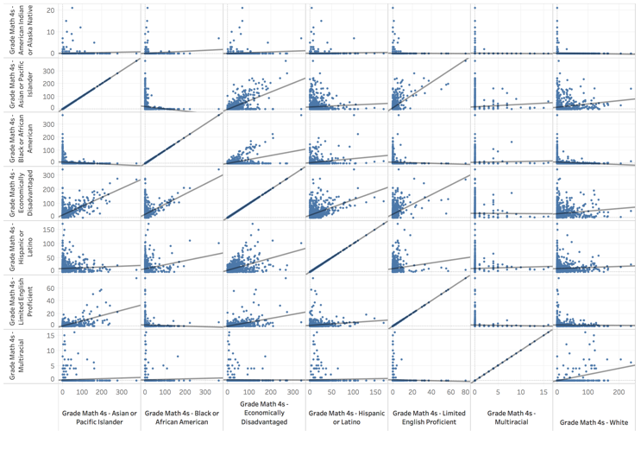

It doesn’t seem like there is a clear relationship between the grades of Hispanic groups and that of Black groups. However, on comparing with other student groups there seems to be a positive co-relation between GPA of economically disadvantaged and that of other ethnicities. The data also shows that most students that studied with economically disadvantaged students also scored higher.

**Tableau inspires me** to explore data in a way I never imagined I would do. I learned how to deal with and visualize geo location data for the first time ever. I also learned how to create stories out of the data. Writing stories is almost equivalent to writing/telling stories in the real world.

**Tableau Review**

I believe tableau is a good visualization tool. However, there are many improvements to make in the tool. I feel that the following are some important features that are important:

* Add feature to schedule email delivery of the dashboards
* Add feature to create summarized dataset from existing data and build dashboards on top of summarized data. I had to create a summarized dataset, save it in excel and them import as new dataset.
* Add feature to set sheet transparency in a dashboard with many sheets. I tried to create a dashboard with a semi-transparent visualization that I wanted to place on top of the others. I could not find this feature in tableau.